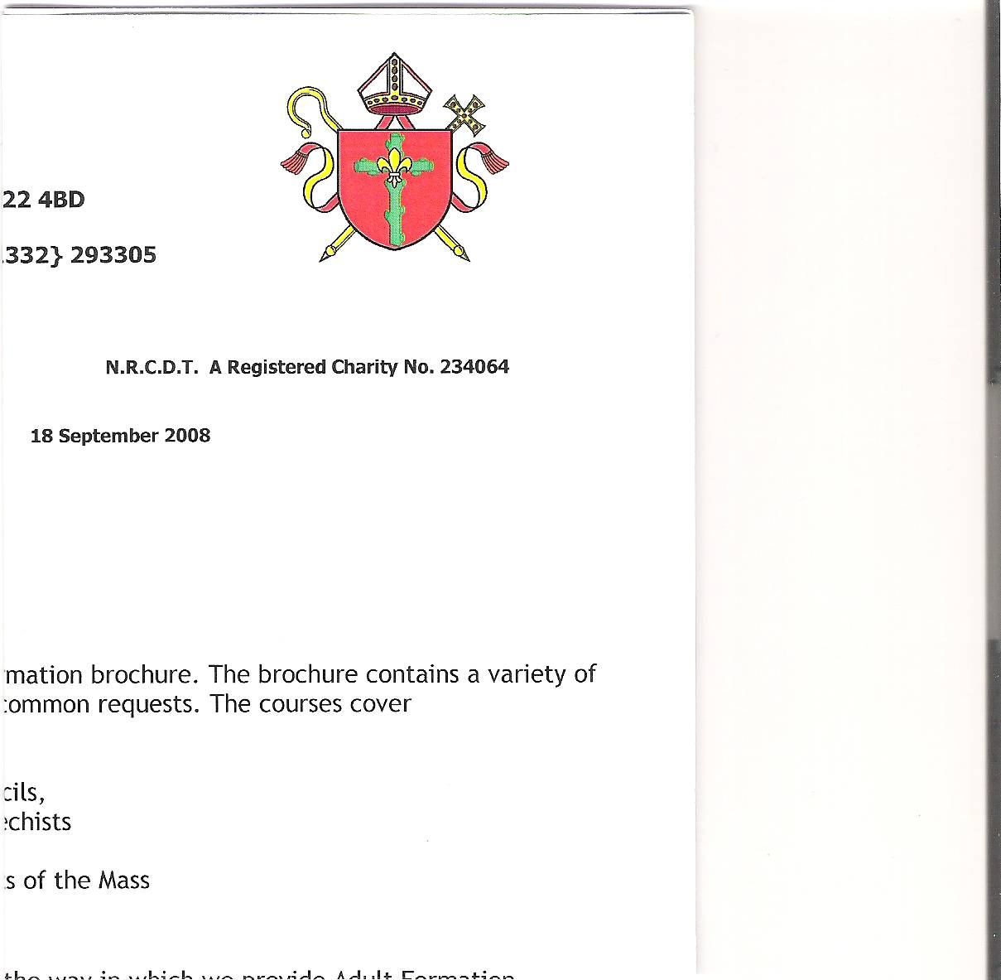

**Holy Cross Parish**

**Hucknall**

**HOLY CROSS PARISH PASTORAL COUNCIL MEETING**

**21st February 2024**

**ATTENDEES:** **APOLOGIES:**

Fr. Richard Hardstaff - President Vaughn Gallagher

Simon Clunie- Chair Olimpia Blaj

Lauren Whitehouse - Secretary

Vivien Flynn

Bill Flynn

Sue Hanson

Lisa Hunka

Chris Wisniewski

Jackie Ortega

Lucas Ortega

Andy Butkevicus

**WELCOME AND APOLOGIES**

Following the opening prayer, Simon welcomed everyone to the meeting. Vaughn was unable to attend and sent their apologies.

**REVIEW OF MINUTES OF LAST MEETING 18th October 2023**

The Minutes were approved as a correct interpretation of the meeting held on 18th October 2023.

**MATTERS ARISING**

Matters arising are dealt with under the following headings – Finances and Health and Safety.

**FINANCES**

The contract for the decorating of the church and presbytery has quoted an extra £2000 to clean the guttering and the windows. An interim report is to be requested from the office to look at the breakdown of costs and the work completed so far.

**Action Point: Sue to obtain the interim report.**

**Health and Safety**

The Fire Safety Report has been published and has been posted at the back of church and in the meeting room. Before taking action the Council have decided to seek advice. They wish to ascertain if the Church may be exempt from creating another fire exit due to the age of the building and to seek advice on the responsibilities arising from the Fire Safety Report.

**Action Point: Simon is to make contact with Catherine Scholes and arrange for her to come and look around the Church and discuss the report.**

**Safeguarding**

No updates

**Fundraising**

The Church requires a new heating system. Fundraising is required to raise the funds. A fundraising thermometer will be placed at the back of the church to allow everyone to track the progress.

The following methods to raise funds were discussed.

Gift Aid

More people are putting loose change into the collection dishes than using envelopes or paying by standing order. The church can only claim gift aid of loose change up to a value of £8000 per year. Gift aid is a valuable source of income.

To encourage the congregation to use standing orders Lucs will give four talks to the church about gift aid, its benefits and how it works. regular donations over the course of 4 weeks starting from 17th March. Forms are already available at the back of church.

**Action point: Lucas to set dates, Viv to check enough forms are at the back of Church.**

Gift aid can be tracked through the envelopes. After the drive for standing orders, the Office will look into ordering envelopes without envelopes for second collection to lower the cost of ordering the envelopes.

**Action point: Lauren to contact the office to check costing of envelopes.**

200 Club

Pre covid there was a weekly draw and we are looking into reviving it.

**Action point: Andy to make contact with Breege.**

**Church Heating**

There have been two quotes to install new church heating. The company who originally installed the heating said they would change the radiators. However, it would require a new gas supply and the involvement of the council to dig up the road to lay the pipes. The other company would install air heaters which would be on the side walls and on the ceiling.

A subcommittee is to be set up to look at these quotes and other alternatives of heating the church.

**Action point: Sue to look into grants and lottery funding.**

**Action point: Simon to ask Vaughn if he will set it up and head it.**

**Pastoral and Liturgical**

There are a number of announcements and praise to be given.

Father has started his Lenton visits.

On Maundy Thursday, after the service, there will be silent prayer and a Night Prayer at the church.

To increase involvement with CAFOD within the church, Chris has suggested bringing in guest speakers and hosting more events like the film showing last year.

**Action Point: Chris is to look at setting up a liturgy group for special events in the year.**

The council would like to recognise and thank Martin for his music and hard work with the choir. There was a low turn-out for the Carol Service. To improve attendance at this wonderful event in 2024, a discussion is to be held to make it a ticketed event.

**Action Point: Lauren to raise the idea of ticketing with Martin.**

The council would also like to recognise Michael Hallam’s work with the altar servers. The number of altar servers has now risen to eleven.

**Action point: no action required**

**AOB**

At the end of mass, the congregation should leave quietly to allow people to remain for silent prayer and contemplation.

**Action point: Father to address the congregation and remind people to leave quietly.**

**Concluding Prayer**

Father said the concluding prayer and the meeting closed at 8.30pm.

**The date of the next meeting is 5th June 2024 at 7pm.**